One To One Hibernate Diagrams

# ER Diagram

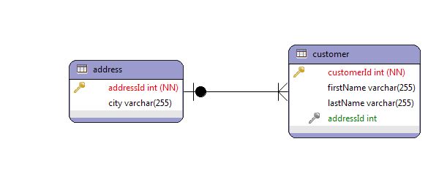

# Class Diagram

